I am building Servlet application by Tomcat web server. How can I change default page from index.html to home.html ?

Ans1:

To change the default page from **index.html** to **home.html** in a Servlet application running on a Tomcat web server, you need to modify the **web.xml** configuration file of your application. The **web.xml** file is typically located in the **WEB-INF** directory of your web application.

Here's how you can do it:

1. **Locate web.xml File**: Navigate to the **WEB-INF** directory in your web application’s folder. If there’s no **web.xml** file, you can create one.
2. **Edit web.xml File**: Open the **web.xml** file in a text editor. You'll need to add or modify the **<welcome-file-list>** element to specify **home.html** as the default welcome file.
3. **Add welcome-file-list Element**: If it doesn't exist, add the following XML configuration inside the **<web-app>** element:

<welcome-file-list>

    <welcome-file>home.html</welcome-file>

</welcome-file-list>

If there's already a **<welcome-file-list>** element, you can modify it to include **home.html** as the first **<welcome-file>**.

1. **Example web.xml Configuration**:

<?xml version="1.0" encoding="UTF-8"?>

<web-app xmlns:xsi="http://www.w3.org/2001/XMLSchema-instance"

         xmlns="http://xmlns.jcp.org/xml/ns/javaee"

         xsi:schemaLocation="http://xmlns.jcp.org/xml/ns/javaee

         http://xmlns.jcp.org/xml/ns/javaee/web-app_3_1.xsd"

         version="3.1">

    <welcome-file-list>

        <welcome-file>home.html</welcome-file>

    </welcome-file-list>

    <!-- Other configurations -->

</web-app>

1. **Save and Deploy**: After making the changes, save the **web.xml** file. You'll then need to redeploy your web application to the Tomcat server.
2. **Restart Tomcat**: It's often a good idea to restart the Tomcat server after making changes to the deployment descriptor (**web.xml**).

By doing this, when you access the root URL of your application, Tomcat will now serve **home.html** as the default page instead of **index.html**. This configuration works because Tomcat checks the **web.xml** file for a list of welcome files to display when the root directory is accessed, and it will serve the first file it finds in this list.

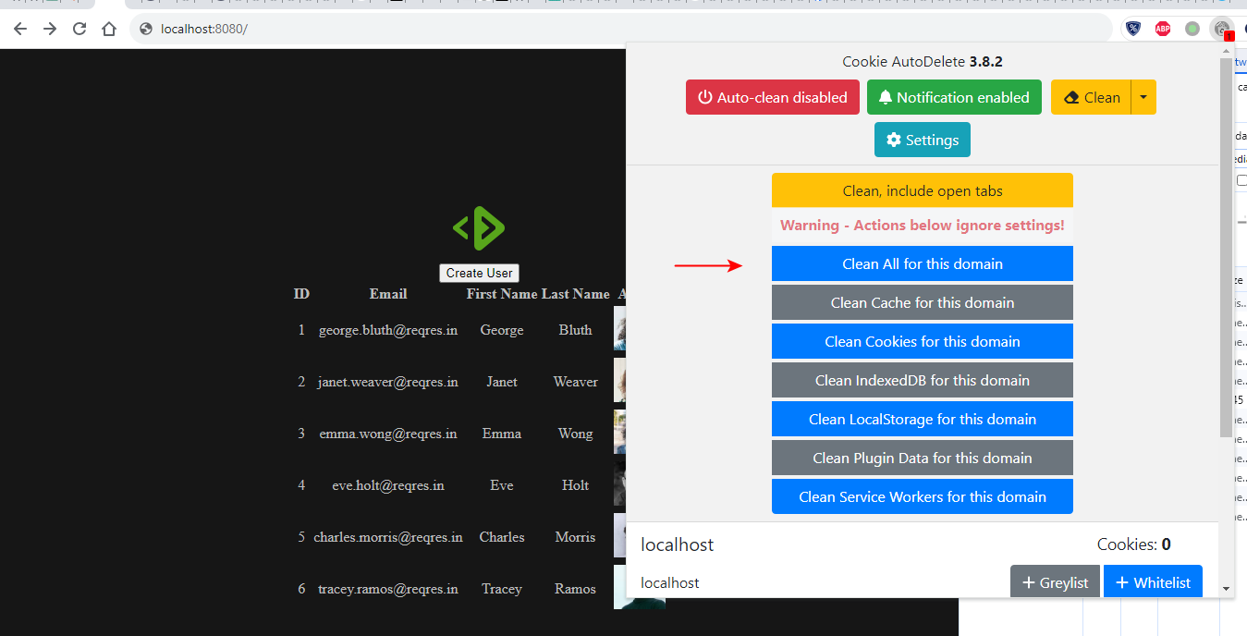

<https://kb.pavietnam.vn/cau-hinh-default-document-tren-plesk.html>

**Cấu hình default document trên hosting windows sử dụng control Panel Plesk 12**

* Thursday 06/05/2021

**Default document là gì ? Vì sao cần cấu hình default document ?**

Default document là  file web mặc định mà khi truy cập vào website sẽ truy cập ngay vào file này mà không cần phải gõ gì thêm.

VD. index.html là file mặc định . domain website là abc.com. Thì truy cập http://abc.com sẽ hiển thị nội dung của trang index.html

Nếu file index.html không được cấu hình  default document thì cần phải truy cập http://abc.com/index.html mới hiển thị nội dung file index.html

Điều này sẽ gây ra sự bất tiện, đây chính là lý do vi sao cần cấu hình default document

Lưu ý, file default document cần lưu tại thư mục gốc chứa web site (VD hosting sử dụng control panel, thư mục chứa website là httpdocs)

Mặc định trên IIS, các trang mặc định (default document) đã được set sẵn theo thứ tự ưu tiên từ trên xuống:

Index.html  
Default.htm

Tuy nhiên , nhiều lập trình viên muốn sử dụng các file khác, VD: home.aspx, trang-chu.html.

Để cấu hình default document, có thể thực hiện theo 1 trong 2 cách sau:

**Cách 1: Cấu hình Default document trên control panel Plesk:**

**1. Login Plesk**

Login Plesk theo đường link: https://[tenmiencuaban]:8443

**Cách 2: Khai báo Default document trong web.config**

Cần khai báo trong thẻ <system.webServer> </system.webServer> 1 đoạn như sau

<configuration>  
     <system.webServer>  
**<defaultDocument enabled=“true”>**  
**<files> <add value=“trang-chu.html“ /></files>**  
**</defaultDocument>**  
     </system.webServer>  
</configuration>

Trong đó **trang-chu.html**chính là tên file cần set default document

Bài hướng dẫn đến đây là kết khúc.

What are the alternative file name for index.html ?

ChatGPT

**ChatGPT**

When considering alternative file names for **index.html**, it's important to understand the context and purpose of the file within the website or application. The name "index.html" is traditionally used for the main or default landing page of a directory in a web server. However, if you're looking for alternative names that might reflect the content or purpose of the page more specifically, here are some suggestions:

1. **home.html** or **homepage.html**: If the file serves as the home page of your site.
2. **main.html**: To indicate it's the main entry point of the site.
3. **start.html**: Suggesting it's the starting point for website navigation.
4. **welcome.html**: If the page serves as a welcome or introductory page.
5. **dashboard.html**: For a main control panel or overview page, often used in web applications.
6. **landing.html**: Common for landing pages, especially in marketing or campaign sites.
7. **default.html**: Another general term for a default page.
8. **base.html**: If the page serves as a template or base for other pages.
9. **overview.html**: If the page provides an overview of the site or service.
10. **intro.html**: Short for "introduction," suitable for pages that introduce the visitor to the site or service.

Remember that if you change the name from **index.html**, you may need to configure your web server accordingly, as it usually looks for **index.html** by default when accessing a directory URL.